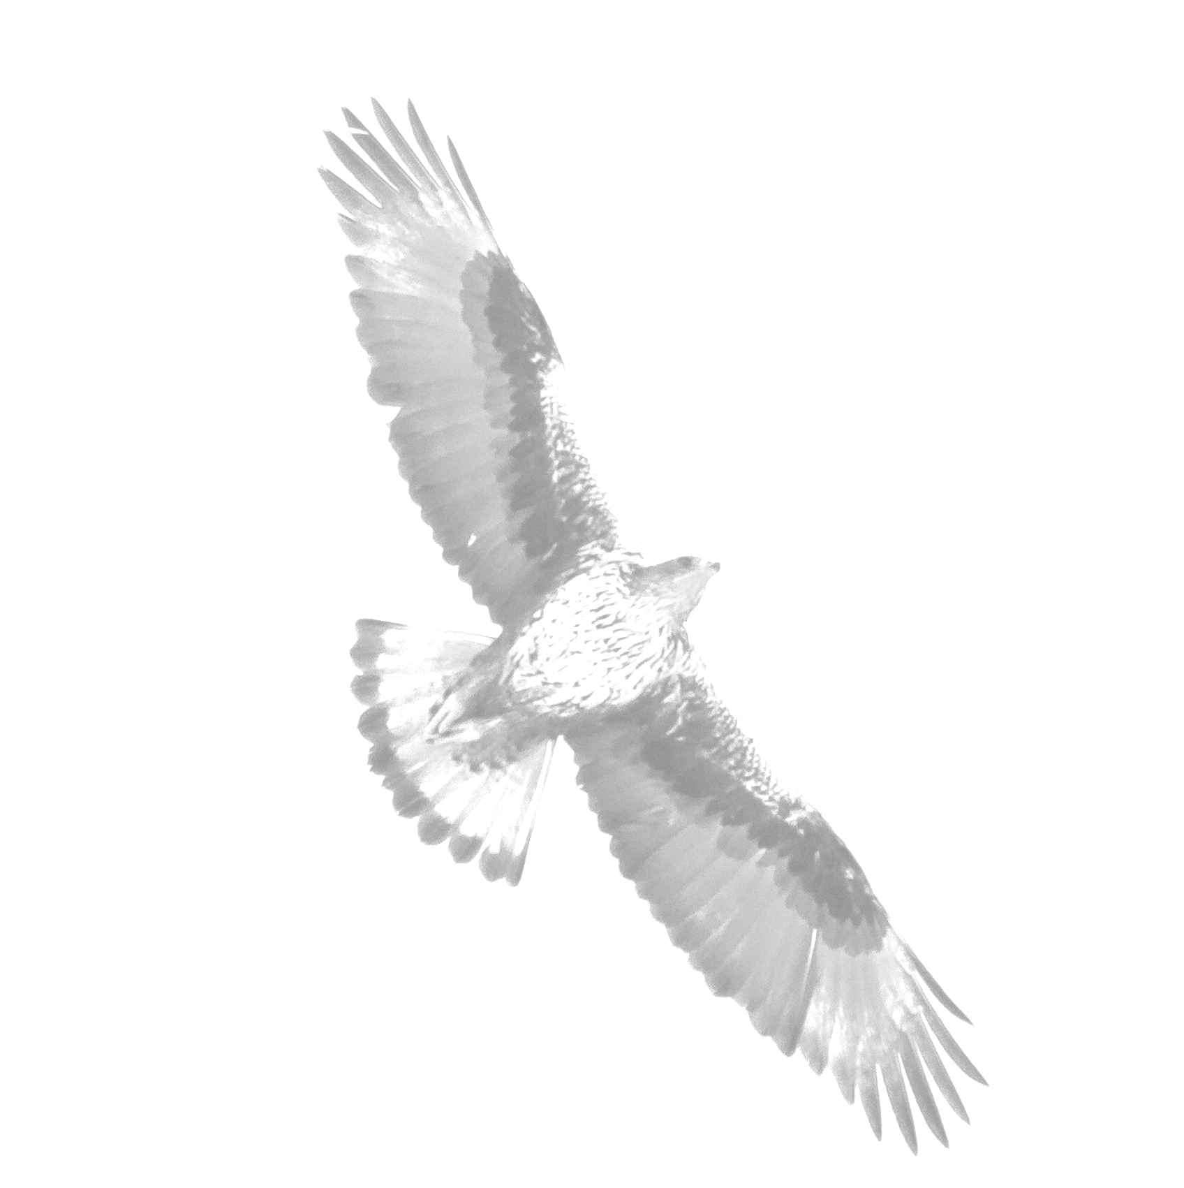
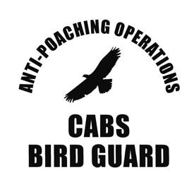
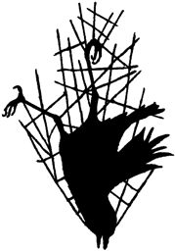
Supporter membership application form Committee Against Bird Slaughter (CABS)

I would like to help to support the protection of migratory birds and wild bird populations from the threat of illegal trapping, hunting, poaching and animal trade and herewith declare my membership to the Committee Against Bird Slaughter (CABS) as a supporter member.

KOMITEE GEGEN DEN VOGELMORD e. V.
Committee Against Bird Slaughter (CABS) An der Ziegelei 8, 53127 Bonn

Name (Print):

Address:

Town /Post Code D.O.B:

The minimum membership fee as a sponsoring member is 25€ per annum. Any additional amount to directly support our operations will be greatly appreciated.

I declare my contribution of [ ] Euro / pounds / dollar per annum.

I agree to the storage of the above personal data until further notice.

Place / Date / Signature:

Your personal reference number will be communicated to you in writing. Our creditor ID of the Bundesbank is DE80 ZZZ0 0000 4121 37

Privacy is important to us. We only save the information you provide in order to contact you as part of the sponsoring membership and to create donation receipts. Your data will not be shared with third parties. You have the right to information at any time and have the right to delete the data in accordance with the provisions of the GDPR.

Thank you

The CABS Team.

